**"DMTech" Ltd. Pleven**

**Product passport  
Fire conventional panel FP9000L – 2/4/6/8**

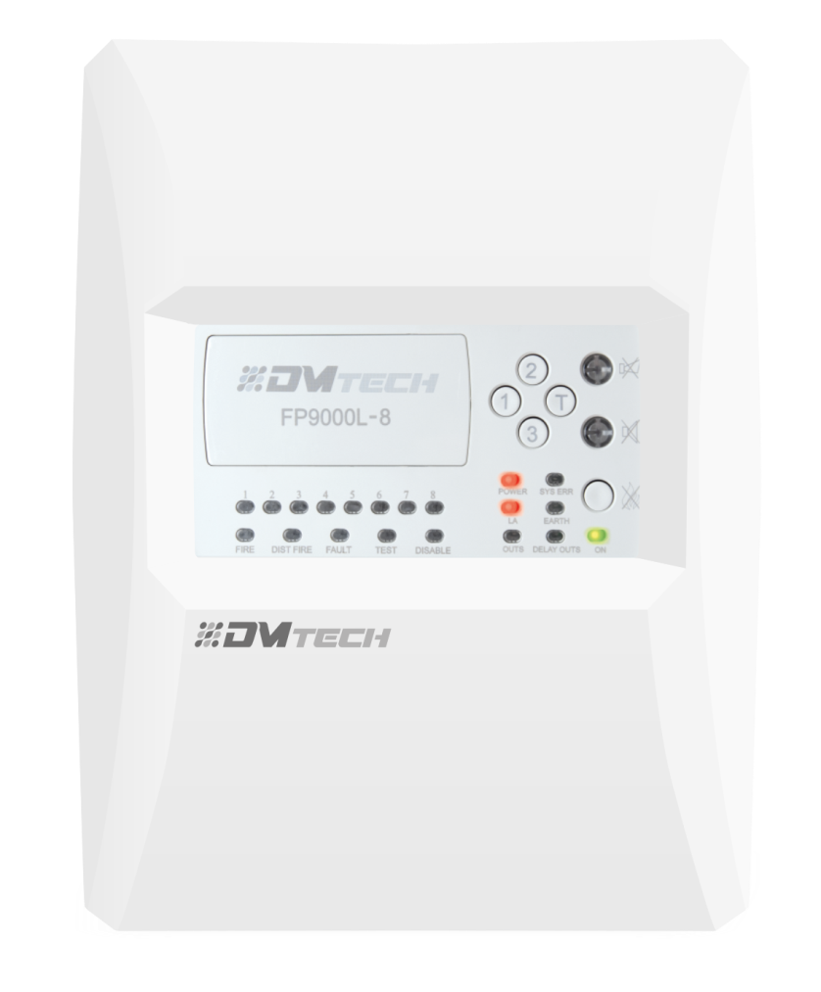

**Technical Parameters**

**Product passport**

**Rev 05:24**

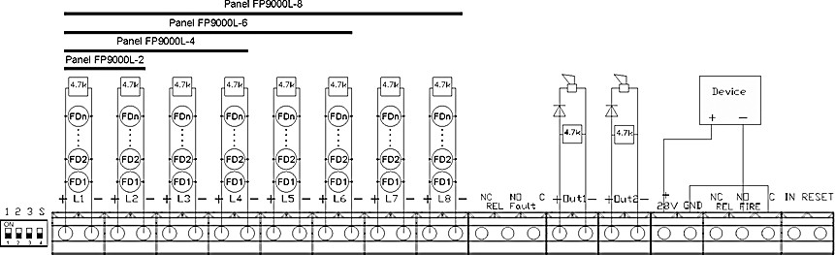

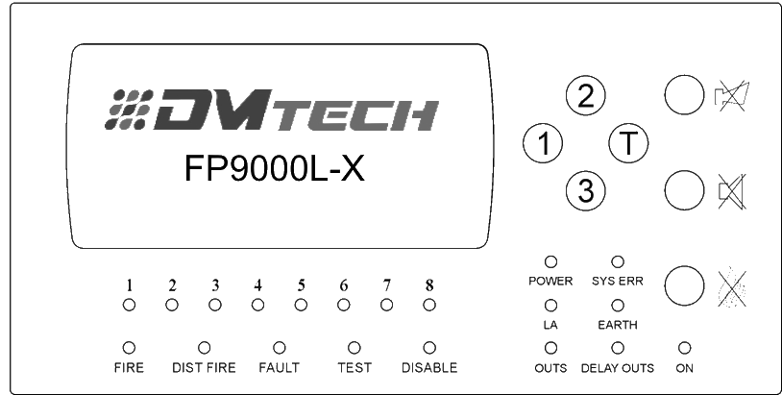

1. **TECHNICAL CHARACTERISTICS**

|  |  |  |
| --- | --- | --- |
| **LINES** | | |
| * **Lines:** | | |
| * Number of lines | **2, 4, 6 or 8** | **Optional** |
| * Maximum number of fire detectors in a line | **32** |  |
| * Type of the joining line | **biconductional** |  |
| * Plume maximum resistance | **100** Ω |  |
| * **Current thresholds in the lines:** | | |
| * Interruption | **to 4 mA** |  |
| * Duty mode | **from 4 to 16 mA** |  |
| * Fire | **from 17 to 70 mA** |  |
| * Fire direct /without delay outputs/ | **from 40 to 70 mA** |  |
| * Short circuit | **> 70 mA** |  |
| * **Lines functional characteristics:** | | |
| * Verification quantity before entering Fire mode: | **2** |  |
| * Verification and regestrating fault in a earth conductor | **yes** | **selectively** |
| **OUTPUTS** | | |
| * **Independent relay output in case of fire alarm:** | | |
| * Quantity | 1 |  |
| * Type | switching | **NC / NO** |
| * Electrical characteristics | 3А/125V AC,  3A/30V DC |  |

|  |  |  |
| --- | --- | --- |
| * **Controllable output in case of fire alarm:** | | |
| * Quantity | 2 |  |
| * Type | potentional relay |  |
| * Electrical characteristics | (19-28)V DC/ 0,5A |  |
| * **Additional relay outputs (module M9000R 2/4/6/8) in case of fire alarm:** | | |
| * Quantity | 2/4/6/8 |  |
| * Type | potentional-free | **NO** |
| * Electrical characteristics | 3А/125V AC,  3A/30V DC |  |
| * **Independent relay output in case of failure:** | | |
| * Quantity | 1 |  |
| * Type | potentional-free,  switching | **NC / NO** |
| * Electrical characteristics | 3А/125V AC,  3A/30V DC |  |
| * **Delay outputs:** | | |
| * Time delay of switching outputs | 0 ÷ 7 minutes |  |
| **POWER SUPPLY** | | |
| * **Mains power** | | |
| * Voltage | **(187-252)V AC** |  |
| * Frequency | **50/60 Hz** |  |
| * Maximum power to mains power | **38W / AC** |  |
| * **Battery power** | | |
| * Battery quantity | **2** |  |
| * Type of the battery | **Lead, gel** |  |
| * Battery rated voltage | **12V DC** |  |
| * Rated power C20 | **1.3Ah, 4.5Ah, 5 Ah** |  |
| * Charger voltage | **27,6 V DC** | **temperature compensated** |
| **Consumption of battery power in standby mode** | | |
| * Configuration with 2 lines | **< 40 mA to 24 V DC** |  |
| * Configuration with 4 lines | **< 50 mA to 24 V DC** |  |
| * Configuration with 6 lines | **< 60 mA to 24 V DC** |  |
| * Configuration with 8 lines | **< 70 mA to 24 V DC** |  |
| **Time needed in security mode when mains power supply is down with battery 12V/ 5Ah** | | |
| * Configuration with 2 lines | **120h** |  |
| * Configuration with 4 lines | **90h** |  |
| * Configuration with 6 lines | **80h** |  |
| * Configuration with 8 lines | **72h** |  |
| **Time needed in security mode when mains power supply is down with battery 12V/1.3Ah** | | |
| * Configuration with 2 lines | **32h** |  |
| **Executive devicess powering** | | |
| * Voltage | **(19-28)V DC** |  |
| * Maximal current (including the controllable outputs current) | **1А** |  |
| **Fuses** | | |
| * Mains power 230V AC | **4,0 A fusible** |  |
| * Battery power | **4,0 А fusible** |  |
| * Powering external devices | **1,85 А automatic** |  |
| * Controllable outputs | **1,1 А automatic** |  |

|  |  |
| --- | --- |
| **Functional characteristics** | |
| * Control of the lines and controllable outputs for fault conditions (short circuit and interruption) and automatic reset; | |
| * Ability to delay controllable and general outputs for fire for a period of **0 to 7 minutes**   after the registration of state Fire with DIP switch; | |
| * Built-in sounder in case of fire – monotonal, continuous with the possibility of exclusion; | |
| * Test mode of each (fire alarm) lines; | |
| * Ability to Disable each of the fire alarm lines; | |
| * Ability to Disable controllable outputs for fire; | |
| * Interface for communication with external devices RS485 and networking /optional/; | |
| * Possibility for GPRS/LAN communication and remote control and monitoring /optional/; | |
| * Possibility Ability to add module relay M9000R-2/4/6/8. The module expands the outputs of the Panel. | |
| * **Over all size** | **310х240х80 mm** |
| * **Weight without batteries** | **1,25 kg** |
| * **Safety degree** | **IP30/ EN 60529** |
| **The panel meets standarts:** | |
| * EN 54-2:1997 | |
| * EN 54-2:1997/A1:2006 | |
| * EN 54-2:1997/AC:1999 | |
| * EN 54-4:1997 | |
| * EN 54-4:1997/A1:2002 | |
| * EN 54-4:1997/A2:2006 | |
| * EN 54-4:1997AC:1999 | |
| * EN 50130-4:2011 | |
| * EN 55022:2006/А1:2007 | |
| * EN 60950-1:2006/А11:2009 | |

1. **WARRANTY**

The manufacturer guarantees the product’s conformity with EN 54-2:, EN54-4:. The warranty period is 36 months from the date of sale, provided that:

* the conditions of storage and transport were met;
* the startup has been done by authorized persons;
* The requirements for operation conditioned in this instruction were met;
* Defects are not caused by natural phenomena and accidents of the plug socket

1. **DELIVEERY COMPOSITION AND COMPLEXITY/SET**

|  |  |
| --- | --- |
| * Fire Station FP 9000L | **1 qty.** |
| * EOL - resistor 4,7kΩ/0,5W: |  |
| - for configuration with 2 lines /FP9000-2/ | **2 qty.** |
| - for configuration with 4 lines /FP9000-4/ | **4 qty.** |
| - for configuration with 6 lines /FP9000-6/ | **6 qty.** |
| - for configuration with 8 lines /FP9000-8/ | **8 qty.** |
| * (EOL) End for controllable output - resistor 4,7kΩ/0,5W; | **2 qty.** |
| * Fuse 4,0А; | **2 qty.** |
| * Connective bridge for batteries; | **1 qty.** |
| * Packaging. | **1 qty.** |

1922 – CPR – 1800

*DMTech wishes you pleasant work!*