
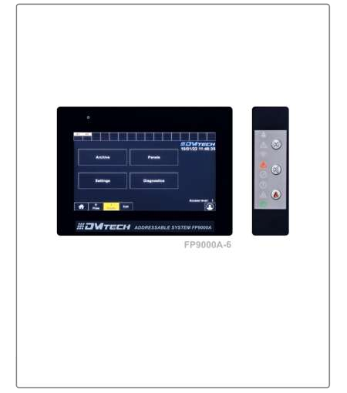

“DMTech”Ltd. Pleven Addressable Fire Alarm Panel FP9000A - 2

Instruction manual
Rev 01:25


Introduction
FP9000A-2 is a modular addressable fire control panel with 2 built-in loops and the ability to add 6 more loop modules. Supports up to 8 loops and 1500 addressable devices. Ability to build a network of 8 addressable panels with visualization from each panel. USB Interface for connection to a computer for programming and quick setup of the control panel. Ability to monitor and manage all events at the panel with LAN interface from a smart phone or computer, remotely, from anywhere in the world, via Internet connectivity.

Purpose
The fire panel FP9000A-2 is designed to optimize the work of users of Fire Alarm Systems. The product is compatible with addressable fire detectors and devices.
The product:
- receives and visualizes information about the status of connected devices and zones;
- forms a controlling influence, to areas from remote fire alarm centers, for their forced exit from the "Fire"
state;
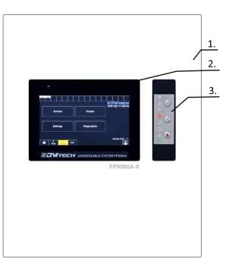
Fig.1 - Control and indication panel
- Characteristics
The front panel of the FP9000A-2 addressable fire alarm panel are presented in Fig.1. Position 1 – front cover; 2 – 7” Touch Display 800x600; 3 – Indication and buttons;
  - Functional characteristics
- Up to 8 loops (DMTech protocol)/ 2 integrated with the possibility of adding 1 + 1 +1+1 loop modules and 2 with additional equipment required.
- Maximum number of addressable devices in a loop:max 250
- Maximum number of addressable devices - 1500
- Maximum current in a loop: up to 700mA
- Zones: 128
- Outputs: 4 relays
- Outputs (monitored, programmable, relay): 2 pcs.
- Log memory: 32000 events
- Display: 7” Touch 800x600
- Language version: multilingual
- Programming: DMTech software (free)

Page 2 of 11

- RS485 Interface for communication with remote control units in a network.
- Possibility to build a network of 8 address panels with a maximum number of 12000 address devices with visualization from each panel.
- 1,2 km distance between panels in a network.
- USB Interface to a PC for programming and quick setup of the control panel.
- LAN remote access interface for monitoring and control.
- Ability to monitor and control all panel events from a smart phone or computer, remotely, from anywhere in the world, via Internet connectivity with Easy Access platform.
- User voltage (18-26,5)V /6,5A.
- Place for 2 batteries 12V/ 18Ah
- Metal box 461х386х85
- Color: white/ anthracite /red/ - optional
- Certified according EN54-2 and EN54-4

Indications of registered events
- Light – LED
- Text – liquid crystal display 7”, 800x600 dots, illuminated
- Sound – built-in sound signal

Power supply (Conforming to EN 54-4)
- Voltage – 26.5V
- Maximum current –6.5A

Dimensions
- Overall dimensions – 461x386x80
- Weight – 5500 g

Content of delivery
- Addressable fire alarm panel FP9000A-2 – 1pc.
- Fuse 6,3A – 1pc.
- Set of resistors 4,7 kΩ
- Transport packaging – 1 pc.

- General information
  - Access levels
    - Access level 1- active by default
This is a level of access for all personnel who is expected to detect and respond to alarms of fire or damage. The following panel options are available:
      - displaying suppressed messages for Fire, Damage, Prohibited components and Zone in test;
      - introduction of reconnaissance time;
      - forced transition from "Fire First Degree" phase to "Fire Second Degree" phase;
      - suppression of the local buzzer;
      - displaying the messages from the inputs;
      - displaying the panel programming data;
      - checking the state of the addressable devices in the loops of the central units connected to it; All panel light indications are visible.
    - Access level 2 – (passwords: 0; 11111; 12222; 133333 … change from settings) This is an access level for personnel who is responsible for safety and are trained and authorized to operate the panel and fire alarm system in the following conditions:
      - Duty mode;
      - Fire;
      - Fault;
Page 3 of 11

      - Disabled component; Information and setup:
      - Access level 2 is entered by entering a password;
      - The following options are available:
        - All available at level 1;
        - Switching off the exits activated in case of fire;
        - Exit from Fire state;
        - The system functions of the panel.

Access level 3 (default access password ‘333333’, recommended to be changed by the user)
This is access level for individuals who are trained and authorized to:
      - Reconfigure the site-specific data recovered in the panel or exchanges connected to it;
      - Carry out the maintenance of the built fire alarm system.
Access level 3 is accessed by entering a password. the following options are available:
      - All available on levels 1 and 2;
      - Panel setting.

Access level 4
This is an access level for people who are trained and authorized by the manufacturer to repair the panel and change its firmware. All functions from levels 1, 2 and 3 are available. Special funds are required to enter this level.

Statuses, Indication and Home Screen
    - Indication – in Fig.2 is shown the indications of the FP900A-6 panel. It consists of eight fields with light indication and three buttons (two of which with indication). The following table describes their functionality:
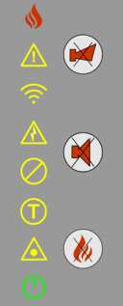
Indication | Description
 | Fire;
 | Indication of damage, lights up in the presence of damage regardless of the type;
 | Indication of lack of communication with any modules (specifically, it is written on the display which control is not communicating);
 | Fault when there is no power (lights up when there is no power or batteries);
 | Lights up in the presence of prohibitions;
 | Signaling for switching to the system test mode, lights up in yellow;
 | Alarm for system failure, accompanied by an audible alarm. In the presence of this damage, the Panel does not function correctly
 | Indictor for the working status of the panel, lights up in green;

Page 4 of 11

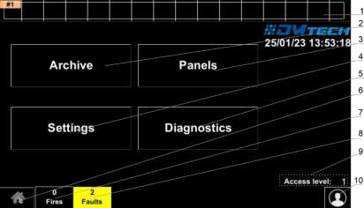
    - Initial screen of the panel – in Fig. 2 is shown the homescreen with the characteristic information areas and function buttons.

Fig. 2
Pos. 1 – Fields for reconnection of 16 exchanges. By holding down on it, the setting options of the respective remote control unit are called up accordingly. Configuring remote panel address, panel name. After activating the corresponding box, the status of each of the central units is visualized. Accordingly, with yellow for failure, red for fire and orange for lack of communication. Pos. 2 - Archive button - with this button you can access the list of events available in the panel.
Pos. 3 - Panel button - this button displays information about the central units connected to the panel (network address, name of the central unit, number of devices, etc.)
Pos. 4 - Settings button - gives access to the options of the panel itself in order to configure (access level, language and others)
Pos. 5 – Diagnostics button – this menu provides information specific to the panel and access to the panel test tools Pos. 6 – The button returns the user to the navigation screen
Pos. 7 – Shows the number of reported fires. It is colored Red. The button calls up a list of the events detected by switched switchboards. Each addition of an event is also signaled with a specific sound signal characteristic of the "FIRE ALARM" mode.
Pos. 8 - Shows the number of reported errors from all connected exchanges. It is colored yellow. When the button is pressed, a detailed list of reported errors is displayed on the screen, respectively by date and time.
Pos. 9 – This position shows the current access level (Default Level 1)
Pos. 10 – This button changes the access level. By entering the corresponding password to Access Level 1, 2, 3 or 4 the user passes between the Levels. Accordingly, he receives the rights based on each access level.

    - Panel status the panel can exist in seven basic states (Table 1):

Table 1
Panel status | Description
Duty mode | A state in which fire detectors are connected to the panel and are working normally
Fire | Condition when a fire detector is triggered in a zone. It triggers the corresponding  executive logic
Fault | State when a fault is registered in one of the fire detectors connected to the panel or  when the connection with a central unit is lost. Logging a fault in the panel.
A forbidden component | The panel enters the Disabled Component state after a manual operation to disable a component - a fire alarm zone, an addressable device or a controllable output of any  of the units connected to it.
Test | State resulting from a manual operation for the panel outputs in "test".

Page 5 of 11

Information and management | The panel enters the Information and Control state when the main menu is activated. In this state, information about the panel and its connected remote centers is displayed  and control data is entered.
Setup | The panel enters the Setup state when the "Setup" submenu is activated from the Information and Control state. In this state, the configuration parameters of the panel  are set.
At any time, the panel can be in one of the states listed, or in any combination of the states: Fire, Fault, Disabled Component, Test, and Information and Control.
The states Standby and Setup cannot be combined with another state:
- the panel enters Standby mode when exiting all other states;
- entering the Setup state causes exit from the other states.

Control and indications
Table 2 describes the main purpose of the control bodies
LED  Indication | Description
FIRE | FIRE INDICATOR. Illuminates permanently in the event of a fire alarm event  following a signal from an automatic or manual fire detector or other external device connected to the panel input.
DIST FIRE | DISTANT FIRE INDICATOR. Illuminates continuously (red) in case of a fire alarm event in a remote control panel after a signal from an automatic or manual fire  detector or other external device connected to the inputs of the remote panel.
FAULT | DAMAGE. Illuminates continuously (yellow) in case of system failure.
TEST | TEST. Steady on (yellow) when performing a system test.
DISABLE | Prohibited Component – illuminates the "Prohibited Component" indicator with a  steady yellow light
POWER | POWER FAILURE. Lights up constantly (yellow) in the event of a 220V power  supply or battery failure.
SYS ERR | CPU FAILURE. Steady on in the event of a main processor failure.
TRANSM | transmission of a fire message to a remote center
COMMUN | data transmission over the network - steady yellow light
OUTS | Fault in controllable outputs - "Fault in controllable output" indicator lights up with  a constant yellow light
DELAY OUT | "Output delay" indicator - constant yellow light

Terminal order on the panel – in Fig. 3 is show the terminal block of the panel
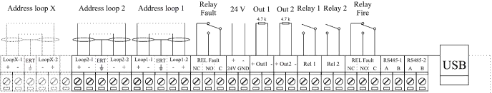
Fig.3 - Terminal block on the main board

Description of the main positions:
- Address loop 1, 2, X (+ LOOP - / + ERT / - LOOP +) – terminal strip for connecting Loops to the fire alarm panel; those marked with a “X” are optionally added by M9000A LOOP expander module;
- Relay Fault – the fault relay is activated when the panel is in fault mode – 3 positions provided for NC (default) condition and NO condition;

Page 6 of 11

- 24V – user power supply;
- Out 1 – Monitored output OUT1 – a 4,7 kΩ terminating resistor shall be connected in parallel to the device far off from the panel
- Out 2 – Monitored output OUT2 – a 4,7 kΩ terminating resistor shall be connected in parallel to the device far off from the panel
- Relay 1 – Programmable relay 1 – the relay function shall be assigned in settings menu;
- Relay 2 – Programmable relay 2 – the relay function shall be assigned in settings menu;
- Relay Fire – the fire relay is activated when the panel is in fire mode – 3 positions provided for NC (default) condition and NO condition;
- USB – USB B / micro connector; communication with the fire alarm panel from a computer via specialized software

Connecting panel to repeater
Completed via RS485 communication line (wire length 1,2 km). The samples in the figure below should be tied to the communication line. The beginning and the end of the communication line are closed by means of end element 120Ω.
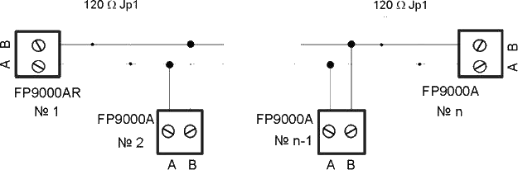
Fig.4
    - Connecting M9000A LOOP expander module to the FP9000A-2 panel
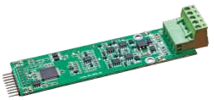
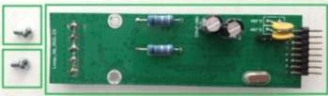
The M9000A LOOP (Fig. 5) is a loop expander for 1 loop in DMTech Addressable fire alarm systems that supports DMTech communication protocol.
Fig.5
FP9000A-2 panel can be expanded up to 6 loops. The module is attached to the panel’s PCB board via pins and fixed by two M3x6 screws at the marked with white circle locations (Fig. 6).

Page 7 of 11

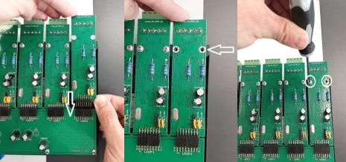
Fig. 6

The connection of the loop to the module's terminals is the same as the one of the fire panel's terminals.

Connecting devices to a loop
A terminal strip and an example for connecting devices to the loop are shown in Fig. 7. Up to 250 devices can be connected to the loop.

ATTENTION: It is recommendable that the first, the last device and each 32nd device in the loop have a built-in short circuit isolator! In the event of a short circuit, only the detectors between the first and the 32nd with built-in isolators will fail.
The cross-section and the Ohm resistance of the cable used for connecting the devices to the loop shall be carefully assessed, the loop length varies.
*For convenience, a calculator has been developed for calculating the loop length and the cable cross section according to specified number and type of devices. - www.dmtech-ltd.com
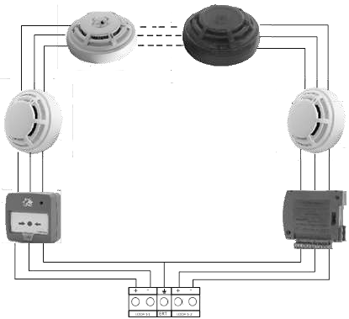
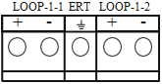

Fig. 7 - Example of devices connected in a loop

Page 8 of 11

    - Connection of signaling devices


Monitored outputs OUT1 and OUT2 provide 24VDC 0.5A to load, connected between them and a mass*.
A 4.7 кОhm terminating resistor shall be connected in parallel to the device far off from the panel in the loop, so the panel is able to check the loop integrity – see Fig.8.
Signaling or other devices can be connected to each monitored output OUT 1, OUT2 - Fig. 8. Device’s maximum consumption shall not exceed 0.5A. A 4.7 kΩ terminating resistor must be connected in parallel to the loop.


R 4.7kΩ
+OUT1-

Fig. 8 – Example of an exit sign device connected to an output

Connection of storage battery
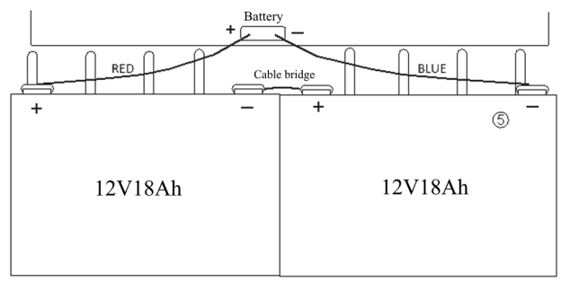
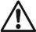
Storage battery connecting pins are situated at the base of the PCB. The connection to the storage battery is shown in Fig 9. The fire alarm panel box has a cable, with installed cable ear terminals for serial connection of storage batteries.

WARNING: Storage battery must be charged at maximum current value I = 2A and voltage U = 27.2V ±1%.
Fig. 9 Connecting the storage batteries

Page 9 of 11

Connection to main supply
Power to the fire alarm panel is provided by connecting the main power supply main cable to a 220V terminal, installed in fire alarm panel’s box. The wiring between the 220V terminal and the power supply unit is done by the manufacturer.

Status Standby mode
  - Description
The panel is in Standby mode when it is not in any of the other six states (no faults, fires, test or prohibition status in the built system and is connected to all remote control units).

Indication
LED indication and sound signaling
Only the green LED indicator ("Power") lights up. The local buzzer is not triggered.
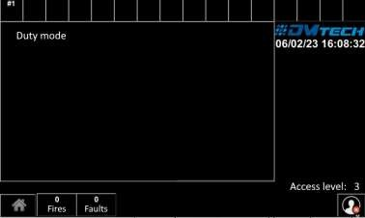
Fig. 10

Fire condition
  - Description
The panel enters the Fire condition when the fire detector of the panel(s) connected to it is activated. The panel may be in "Fire" condition:
- one or several zones from one panel;
- one or more zones from different panels.
Exiting this state is possible only by manual operation - pressing a button at access level 2 or higher (default password '0').
The panel is in Fire condition until the fire is reset.

Indication

    - LED indication and signaling
In this state, the general indicator lights up with a red flashing light (“Fire”). The local buzzer emits an intermittent signal (0.5s sound, 0.5s pause) if not suppressed by button (“Stop alarm”).

Fault condition
  - Description
The panel enters this state when registering;
- Fault in the panel: fatal system failure, damage to the processor program, failure in communication with the headquarters, damage to the clock, failure in the mains supply, battery power failure.

Page 10 of 11

- Fault in a remote control panel connected to the panel: failure in communication with the panels, damaged clock, damaged panel, failure in a module, damaged circuit - short circuit or interruption, uninitialized loop, a greater number of devices in a fire alarm loop, fault in a
zone – when a fault occurs in a device included in the zone, removed device, device failure, tripped device isolator, tripped isolator to Power loop of device, contaminated sensor (only for fire detectors with optical-smoke part), error in communication with a device, uninitialized device (a new device detected in the loop), exchanged devices, a different device ID, different device type, different device class, failure in a controllable output – short circuit or interruption, failure in the mains supply, battery power failure, short circuit to a grounded wire, circuit power failure, power failure of external devices, low power – discharged battery when mains power fails.
The panel is in fault condition until all faults have been rectified.

Indication
    - Led indication and sound signaling
The LED indication is a combination of three indicators glowing with a constant yellow light:

LED indication | Sound signaling | Fault
 “Fault”   “System fault” | Continuous signal | Fatal system fault
 “Fault”   “Power fault” | Interrupted signal (1s sound, 1s pause) | Power fault

The local buzzer can be suppressed with a button  (“Stop alarm”).

DMTech wishes you pleasant work!

Page 11 of 11

